**Question 1: Orders and Relations (20 points)**

1. Give a definition of a partial order on the set of positive real numbers that has no minimal element and no maximal element. Justify your answer. Give a definition of a partial order on the natural numbers that has unlimited number of minimal elements.

Give a definition of a partial order on the natural numbers that has unlimited number of minimal elements

This set provides us with all composite numbers as a or b since they can be divided by another natural number in b. In addition, this provides the set of prime numbers as minimal elements because those elements can only divide by itself when a = b. The prime numbers can divide into other elements, but there will be an infinite amount of prime numbers serving as an infinite amount of minimal elements.

1. Let S be the set of all subsets of {1, 2, 3, 4}. Suppose *A, B* ∈ *S*. Sets *A,B* are related if and only if there exists an element x ∈ A that can be swapped for another element such that the new set is equivalent toy. For example {1, 2, 4} is related to {1, 2, 3}. You may not swap to an element that is already in y. For example: {1, 2, 4} is not related to {1, 2, 2}. Determine if this relation is symmetric, transitive, reflexive, anti-symmetric. Draw the graph for this relation and for the graph R ◦ R. Is the latter reflexive? Justify your answer.



* S={(∅), (1),(2),(3),(4),(1,2),(1,3),(1,4),(2,3),(2,4),(3,4),(1,2,3),(1,2,4), (1, 3, 4),(2,3,4), (1, 2, 3, 4)}

R ◦ R:

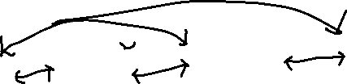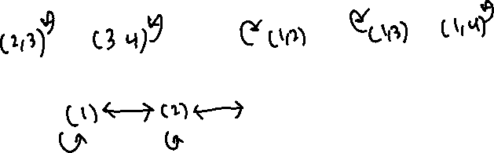

The graph for the relation itself

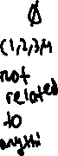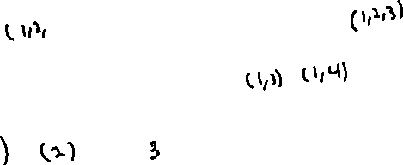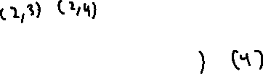

* **Not Reflexive (based on an interpretation of the question).**
  + This is going with the interpretation that an element in X cannot be swapped for the same element in Y
    - If there is (1, 2) and (1, 2), you cannot swap 2 with 2 or 1 with 1.
  + Cannot swap to an element in y that already exists in x. This means that an element in A cannot be swapped for an identical element in B. So A would have to swap for an element in B that is not in the set A, meaning the set cannot remain identical.

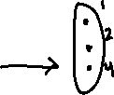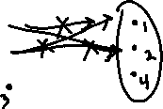

* **Symmetric**
  + For every (a, b), there will be a (b, a)
  + For any elements that the set A can swap with B, it must not exist in A. If (a, b) exists in A, then that there is an element in B is that not in A and that there is an element in A that is not in B.
  + This means that (b, a) is possible because (a, b) means there’s an element in b that is not in a, allowing the swap to go both ways.



* **Not anti-symmetric**
* If (x, y) then, there are no pairs (y, x) where x = y
* Every related pairs can swap with each other
  + All of the (x, y) and (y, x) pairs are related and none of them are x ≠ y
  + (0) is related to (1) just as how (1) is related to (0) while 1 ≠ 0.
* **Not transitive**
  + If (x, y) and (y, z), then (x, z)
* In the sets of R, (1) is related to (2) and (2) is related to (1, 3) but (1) is not related to (1, 3).
  + Not transitive.

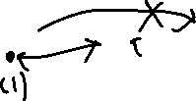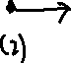

(c) A group of primary school kids are decorating their classroom. They have each been given a paper 5-point snowflake, with 6 black dots (as shown below)

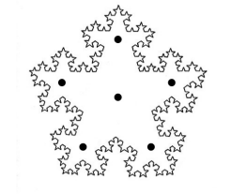

Using their hole punch, they are allowed to punch out as many of the black dots as they like. Once they have finished their hole punching, they may take their snowflake and tape it on the window. Of course as they walk to the window, they may inadvertently rotate it or flip it over. Define a relation, R, on the set of possible snowflakes as follows: two snowflakes are considered related if one of them can be rotated and/or flipped over to look identical to the other. In the example below, the two snowflakes are related. Justify why this is an equivalence relation. Define the equivalence classes for this relation

* Symmetry for the snowflakes is based on vertex symmetry. The snowflake can be flipped based on where the black dot is and yield another similar looking structure.
* This creates a set is an equivalence relation because the snowflake can be partitioned into distinct groups based on their symmetry.
  + While one region can be rotated to resemble another, these 5 are distinct from one another.
* The two snowflakes below are an equivalence relation because they share 4 black dots on the outer vertex, 1 white circle in the center, and 1 white circle on one of the edges. You can rotate one to yield the same appearance as the other.

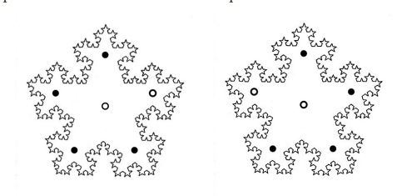



* Equivalence class relations add up to 26.

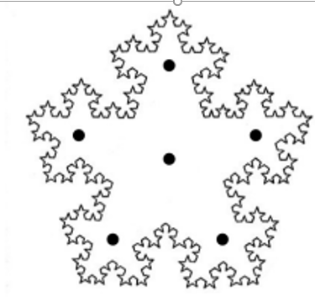  

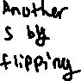

  

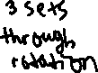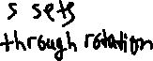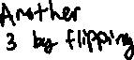

These are 6 equivalent classes where the dot in the center is black. If the dot in the center was white, this would yield another 6 equivalent classes using the same arrangements.

However, the number of equivalent sets is doubled because the center dot can be black or white, so there is an equivalent set for the same types of sets with a white dot in the center.

There are 6 equivalence classes drawn out above. With the variants where the center dot is white, there is a total of 12 equivalence classes for the snowflakes.

**Question 2: Proofs (20 points)**

1. Let n be any natural number that is not a multiple of 5, n ≥ 1. Let m = n2. Prove that *m* is either one more than a multiple of 5 or one less than a multiple of 5.

Proof by cases:

|  |  |
| --- | --- |
| Cases where N is related to 5 | Results |
| N=5k | Multiple of 5 only, fails |
| N=5k+1 | One more than a multiple of 5 |
| N = 5k+2 | Two more than a multiple of 5 |
| N=5k+3 | Three more than a multiple of 5 |
| N=5k+4 (Same as 5k-1) | One less than a multiple of 5 |

Every number can be represented as a number of one of the five equations above. If n is not a multiple of 5, then it must be represented as 5k+1 or as 5k-1 as m must be either one more or one less than a multiple of 5.

Proof by cases:

Because every natural number can be represented as a case of (5k + 1), (5k + 2), (5k + 3), or (5k - 1), the squares of those sets show that no matter what value k is, the value of k will always end up as a multiple of 5 with the addition of 1, 4, or 9 which is one number above or below a multiple of 5. This proves that every number of n that isn’t a multiple of 5 will always end up as a 5k ± one more a multiple of 5 or one less than a multiple of 5.

1. A law firm has 25 new employees. They are arranged in the auditorium in 5 rows of 5 people each (in a grid formation). An announcement is made that asks each employee to turn to exactly one neighbor (front/back/left/right) and shake their hand. An employee may not shake the hand of more than one person. Prove that regardless of who shakes whose hand, the maximum number of handshakes that occur is 12.

|  |  |  |  |  |
| --- | --- | --- | --- | --- |
| 1 | 3 | 6 | 8 | 11 |
| 1 | 5 | 6 | 10 | 12 |
| 2 | 4 | 7 | 9 | 12 |
| 2 | 4 | 7 | 9 | 11 |
| 3 | 5 | 8 | 10 | 13 |

* A 5x5 grid is an odd number of people and arrangements
  + The black squares can pair with only the white squares and vice versa.
  + In the diagram above, there are 13 black squares, but only 12 white squares to match with the black squares. One black square will be leftover.
* An employee can shake the hands of only one person, this means each man/woman has to be paired with an adjacent person. Only 2 people can be removed from the grid at all times.
* 25 people is an uneven amount of people that are required to shake hands but only an even number of people can be taken out at each time.
  + There will always be one person who does not get paired.
  + Because one will always be left over, he/she does not handshake with anyone.
    - Condition states that an employee cannot shake with more than one person. This implies means he/she doesn’t have to shake hands with anybody.
  + The lowest even number of 25 is 24. This is a scenario where 12 people handshakes with the other, the closest possible maximum number of handshakes for 25 people.
* In an NxN grid, the only way for the maximum number to match n2 is if n is an even number.
  + That way, n2 is an even number and all white and black squares can be paired with a unique, adjacent square.
  + In the scenario where n2 is an odd number, then the maximum of people who can shake hands can only be one less of n2.
    - 52 = 25. One less of this is 24, only 24 people will shake hands, leaving a total of 12 handshakes.

1. An office is trying to distribute their 242 magazines into their 10 different waiting rooms. The magazines cover 11 different subjects, and each subject has exactly 22 magazines. The owner would like to mix up the magazines as much as possible so that each waiting room doesn’t have too many magazines from the same subject. Prove that no matter how the owner distributes the magazines, there is at least one waiting room that has three magazines of one subject and three of another.

* Proof by contradiction, assume that no waiting rooms will have more than 3 magazines of one subject and 3 of another subject.
  + In other words, no waiting room would have more than 3 magazines of one subject and no more than 3 of another subject no matter the distribution.
* The requirement was that no waiting room should have no more than 3 magazines of more than one subject.
* Attempting to evenly distribute 1 subject’s worth of magazines means distributing 22 magazines to 10 waiting rooms.
  + Each waiting room can get 2 magazines to stay under the conditions of having no more than 3 magazines of one subject.
  + This means 20 magazines are given out to all 10 waiting rooms, however that leaves 2 extra magazines to be given out.
  + These two magazines must be given to a room, making it so that one or two rooms will have 3 or more magazines of the same subject.
  + **Atleast one waiting room will have 3 or more magazines for one subject**
* In terms of 11 subjects worth of magazines, there are 10 waiting rooms that we can distribute to.
  + If we distribute the magazines based on subjects to each room, each waiting room will get 22 magazines of one subject.
  + This means giving out 10 subjects to 10 waiting rooms, leaving one subject’s worth of magazines to give out.
  + However, as shown described above, we cannot evenly distribute one subject’s worth of magazines without having one or two waiting rooms have atleast 3 magazines.
  + **The 11th subject will have to be present in one of the ten waiting rooms which already have atleast 3 magazines of one subject.**
* Each subject has enough magazines that it isn’t possible to evenly distribute them to each waiting room without having one or two waiting rooms have atleast 3 magazines. On top of that, there are more subjects than waiting rooms, meaning that the 11th subject’s magazines will have to be distributed to the waiting rooms. It is impossible to properly distribute all 22 of the 11th subject’s magazines without having that subject hold more than 3 magazines. **Negation is impossible. Therefore, atleast one waiting room will have three magazines of atleast two subjects.**

**Question 3: Mathematical Induction Part 1 (15 points)**

1. Brian is 18 and likes to borrow his parents car once a day. The car has 7 gallons of gas in it on day one. Brian doesn’t want his parents to know that he borrows it, so every time he takes it, he makes sure that he only uses at most one fifth of the gas that is currently in the tank (hoping they won’t notice). Then he returns the car without filling it up. His parents become suspicious, and start to wonder if Brian is using their car. When they take their car to the grocery store each evening, they always add 1 more gallon than what they used. Determine the minimum amount in the gas tank on the morning of day 2 and day 3. Prove by induction that the amount of gas in the tank each morning is always at least 5 gallons.

Assuming x 2 as f(1) = 7

|  |  |
| --- | --- |
| X (Days) | F(x) (Gasoline) |
| 1 | 7 |
| 2 | 6.6 |
| 3 | 6.28 |
| 4 | 6.024 |

n = k + 1

Assuming f(k) ≥ 5 due to the induction hypothesis, we can substitute 5 into f(k)

As long as f(k) is ≥ 5, then f(k+1) will always be f(k+1) ≥ 5 as well

1. An investor deposits $100 into his account on day 1, $200 into his account on day 2, and $300 into his account on day 3, and $400 into his account on day 4. For every day after that (n > 4), he decides to drastically increase his deposits, and he will deposit the sum of what he deposited on the previous four days. Prove by induction that the amount of money he deposits on any day n ≥ 1 is at most $100 · 2n.

|  |  |  |
| --- | --- | --- |
| Day | Amount | 100*2n |
| 1 | 100 | 200 |
| 2 | 200 | 400 |
| 3 | 300 | 800 |
| 4 | 400 | 1600 |

Substituting N = K+1

I(N) = I(K + 1)

Applying the assumption of I(N) ≤ 100*2n by substituting I(K) with 100*2n along with its counterparts.

Any previous counter parts were k-n days before I(K), so they would require 100*2n-k depending on how many days away from n.

Because the added-up values of the previous 4 days add up to 15/8 * 100 *2k instead of 100 * 2k+1, that means for I(K+1), the sum of the previous 4 values will be less than I(K+1)

1. A second investor has a similar plan. She deposits $100 on day one, $200 on day 2 and $300 on day three. For every day after that (n > 3), the investor deposits the average of her deposits from the previous three days. Show that after a certain point, the daily amount she deposits into her account is always less than $250. Your job is to determine a value k for which the deposit amount is less than $250 for all n ≥ k.

Prove the result by induction.

|  |  |
| --- | --- |
| Day | Amount |
| 1 | 100 |
| 2 | 200 |
| 3 | 300 |
| 4 | 200 |
| 5 | 700/3 |

Strong Induction: Assume that I(5)…I(K) is true for all values

Due to induction hypothesis assuming that I(k) ≤ 250, we can substitute I(k) and its predecessors of I(K-1) and I(k-2) to be 250 as these will also fall under I(K) ≤ 250

As long every variant of I(5), I(6)…I(k) is ≤ 250, then I(k+1) will be $250 or lower.

**Question 4**

1. Suppose we consider problem 4 from practice set 5, where *n* represents the number of viruses in a petri dish. Suppose that the biologist also counts the number of days he/she leave the viruses in the dish. Day 1 corresponds to the first day the virus is placed in the dish, and no reproduction is made. Suppose every day after that (d > 1), at least one virus reproduces. Prove by strong induction on *d* that the number of viruses in the dish after d days is at most 2d+1 − 1.

* A single virus reproduces at most once
* A virus can’t be born and reproduce on the same day

Virus reproduces by creating 2 offspring.

Day 1: 1 virus.

Strong Induction: Assuming that 2 < k < 2d+1-1 for all days up to d.

The viruses in the petri dish

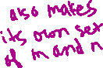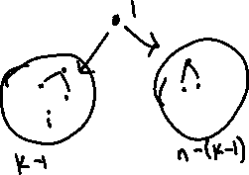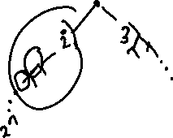

After day 1, the virus reproduces to form a total of 3 viruses. However, the first virus no longer reproduces from that point onward, meaning that only the two offspring of virus 1 will reproduce the next day. From virus 1, each virus can be sectioned recursively into two categories of one of the two offspring while virus 1 has to be sectioned away because it can no longer contribute any further to the virus population (hence, why we subtract 1).

The two offspring, each labelled n and m respectively, can reproduce once to form another set of offspring of n1, m1. They must be removed from the set because they can no longer reproduce again. The recursive set of offspring creating more n and m viruses means that each day creates another set of 2m and 2n.

So on day 1, it is 1 virus. It produces 2m/2 and 2n/2 viruses after the next day and so on while the progenitor no longer reproduces, meaning that there won’t be an extra virus offspring from the set.

Let k + 1 = m + n + 1.

(b) A hospital is trying to determine how to efficiently vaccinate n individuals. Currently the individuals are all waiting in the same waiting room. The individuals are not allowed to move, unless instructed by a health care worker. An individual can only be vaccinated once they are placed alone in a waiting room. The health-care workers can perform only the following tasks:

* A group of n ≥ 2 people can be divided into two non-empty groups and placed into two waiting rooms. This costs $20 for the disinfection of the two rooms.
* If a person is alone in a waiting room, the health care worker can enter and give them a vaccine. This costs $100.

Show by induction that the total cost of separating the individuals and vaccinating all of them is exactly $120n − $20, regardless of the order of the above two steps. You must assume that the health care worker can separate and vaccine in any order

* Setup: Groups of n ≥ 2 are placed into one waiting room who are then taken to an empty waiting room and vaccinated.
* Waiting room is disinfected before taking another person.
* The final person, n can just be vaccinated in waiting room 2. This would mean waiting room 2 needs to be disinfected before vaccinating person n.

*Base case of 2 people:* Two people are in waiting room 2. Person 1 goes to room 1 and gets vaccinated, costing $100. Room is disinfected, costing $20. Person 2 goes to room 1 and gets vaccinated, costing a total of $220. Passes.

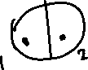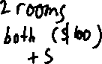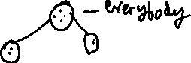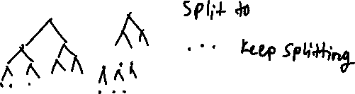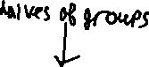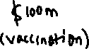

For every n ≥ 2, they can be continuously split into two groups cut in half. Each group can be split until it reaches the base case of 2 people which can be split into each person isolated in a waiting room.

* Each person is vaccinated ($100m and $100n for the two people).
* Two waiting rooms are disinfected after two people get vaccinated ($20m + $20n)
* However, because two rooms are disinfected for each time, all groups will finish with two waiting rooms being disinfected for the price of one (-$20).

**Question 5: Counting Techniques (30 points)**

1. How many different passwords can you make of length n by selecting from the set {a, b, c, d, 0, 1, 2} ? (repeats allowed) What if the password must alternate between letters and numbers?

Assuming the password starts with a letter, it will start with 4n possibilities and the numbers will have 3n possibilities. However, size n will be split between the set of letters and numbers.

If the password starts with letters first

If the password starts with a number, then the two are flipped.

Total possible arrangements:

1. A party room has a circular table with 16 seats. A group of 6 people enter the room. How many different ways are there for the 6 people to sit around the circular table? What if there must be at least one empty seat between each person?

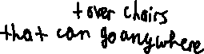

When one person sits down, there are 15 seats remaining for 5 people. When we decide the order of the 6 people to sit down, we get (6-1)! arrangements for the people. 6 chairs are needed for all 6 people, leaving behind 10 chairs to choose from. This becomes a combination of circular permutation and stars and bars. Can use the permutation of circular people to divide the leftover seats.

N = 6 people, k = 10

To determine the number of ways everyone can sit down. The arrangement and order of the people who sits first can be determined immediately.

(n-1)! for the arrangement of people

To determine the arrangement of the chairs, we start with 16 chairs. In order to have atleast one vacant chair next to everyone, that means everyone needs to have an empty chair on their right. If this is fulfilled, it also means everyone has a vacant chair to their left as well because the actual condition is that nobody sits consecutively. This means one chair is decided for a person to sit on while a second chair is designated as the empty chair for the person’s right side.

1. Choose seating order: (6-1)! Arrangements for people
2. Place a chair for everyone to sit on: 6 chairs for 6 people
3. Place an empty chair to everyone’s right side: 6 chairs to everyone’s right side.
4. Place the remaining chairs: 4 chairs left that can go anywhere on the table



1. How many different ways are there of creating teams of sizes 3 and 6 out of a group of 9 people? How many different ways are there of creating three teams of size 3 out of 9 people? The teams are not labelled.

* Indistinguishable bins with indistinguishable objects, but we have a set amount for the two teams.

Can also be expressed as a multinomial problem

How many different ways are there of creating three teams of size 3 out of 9 people?

* Indistinguishable objects and people, but the 3 teams all have a set size of 3.

**Multinomial problem**

Total possible combinations of 9 people: 9!

With 3 different groups, each group has its own permutation of people to arrange: 3!, 3!, 3!

Because teams are not labelled but rather we just choose how to set up 3 teams, so the order must be excluded: 1/3!

1. Suppose we have 6 blocks and we want to make 3 towers. How many ways are there to build 3 towers? (assume the blocks are identical and each tower must have at least one block, and the towers are not labelled). What if the 6 blocks had 6 different colors?

* Indistinguishable objects, indistinguishable bins.

For this scenario, the blocks needed to form 3 towers has to be manually counted as there is no formula to count indistinguishable objects and indistinguishable bins.

{ (1, 1, 4), (1, 2, 3), {2, 2, 2} } are the only possible ways, assuming all 6 blocks must be used.



**Only 3 unique ways to create these 3 towers with each tower holding atleast 1 block.**

* What if the 6 blocks had 6 different colors?

If 6 blocks have different colors, that means they are all distinguishable and must be taken into account when using them. Each tower still requires atleast one block. Inclusion-exclusion principle can be used to remove cases where a tower does not get a block.

* Distinguishable objects, indistinguishable bins.

Sets: Order now matters due to the distinct objects

* (1, 1, 4) – can be rearranged times (choosing items for the tower of size 4).
* (1, 2, 3) – can be arranged different ways.
* (2, 2, 2) – can be arranged different

Alternatively, use inclusion-exclusion principle.

36 = all possibilities

The end result has to be divided by 3! in order to exclude the order of counting the sets.

The end result would be all results where no tower gets no blocks which would be the result where all towers have a block.

1. A cafeteria has 4 different meal types to hand out to 10 children. Assume there is an unlimited supply of pizza, hamburgers, hotdogs and spaghetti. Use inclusion-exclusion to find the number of ways to hand out the meals to the 10 children such that each meal type is received by at least one child.

With inclusion-exclusion principle, must calculate the total number of options and remove the possibilities of one particular meal not being chosen while adding back the overlap between the possibilities of not serving a particular meal.

410: All choices for 4 meals to be distributed to 10 children